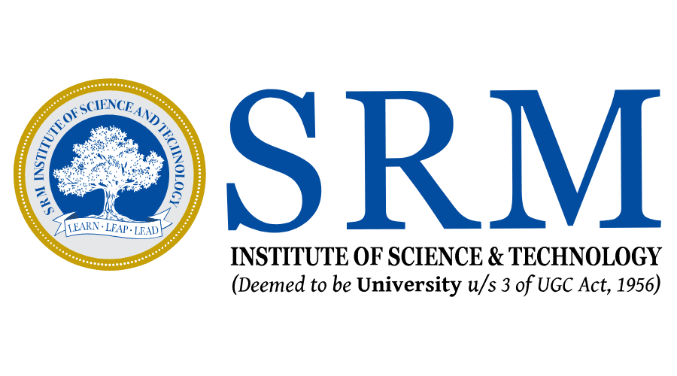

**SRM Institute of Science & Technology, NCR Campus**

**Department of Computer Science & Engineering**

**B. Tech IV Year – Major Project**

**Review – Zero**

Analysis and Future Risk Prediction of Diabetes Mellitus

The number of patients suffering from diabetes in India are increasing rapidly. One of the major reasons behind this can be that most of the population does not take regular check-ups for diabetes. Hence they are unable to take proper precautions and have a risk of getting diabetes in the future. The current methodologies followed by the doctors are manual and can be time consuming, hence we have come up with a solution for this problem, by providing a model in which the user can enter their health report details and know their future risk of having diabetes and if required they can consult a doctor for the same.

In this project, we propose to analyse the Pima Indian diabetes dataset and develop an intelligent system for predicting future risk of diabetes using supervised machine learning algorithms. We would be coding in python using Jupyter Notebook for analysis, training and testing of our model. We would be deploying our prediction model on localhost using Spyder IDE.

Domain: Data Science

Team Member 1 Registration No. (Team Leader): RA1711003030211

Team Member 1 Name (Team Leader): PRAFFULLA KUMAR DUBEY

Team Member 2 Registration No.: RA1711003030230

Team Member 2 Name: UDBHAV NARYANI